**Assignment 1 summary:**

**All requirements are satisfied:**

1. Each basket will only take a set of a fruit and a vegetable.

2. A user will also be able to number the basket from 1~5.

3. Each basket will only take a unique number.

4. A user can change the basket number.

5. A user can change the combination of a fruit and a vegetable in a basket.

**Below are some extra implements in my project:**

**1. Use CSS and images.**

**2. Some rules reminders at the beginning of loading this webpage.**

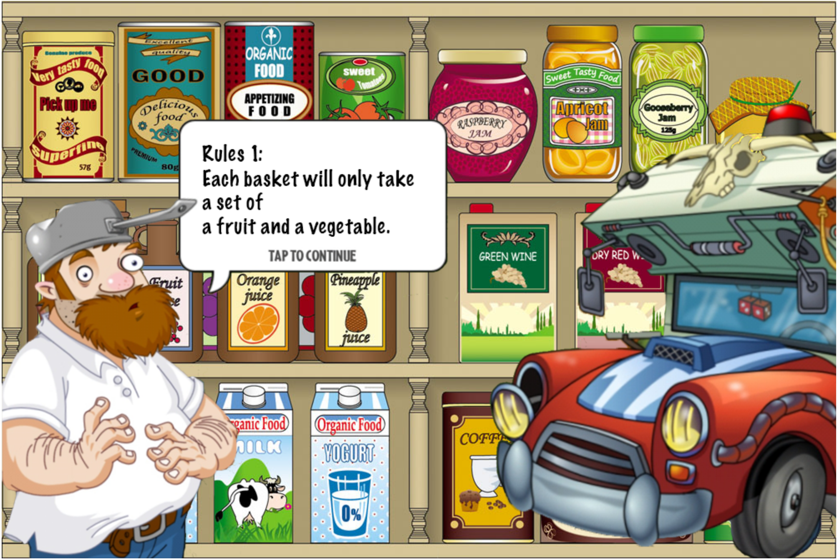

**3. A user can add a single fruit/vegetable or a set of a fruit and a vegetable once.**

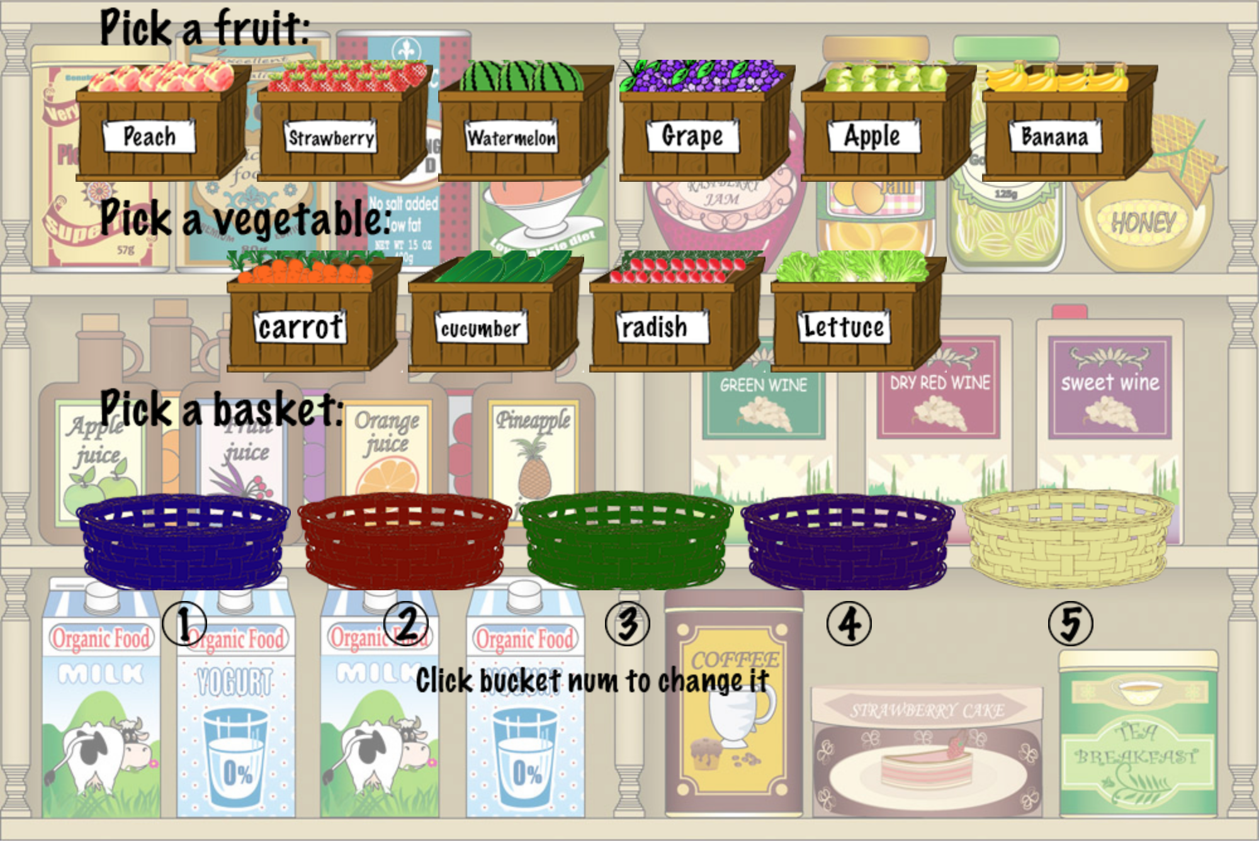

**4. Invalid input check with user input bucket number:**

**If it is not a number between 1-5, there will be an alert.**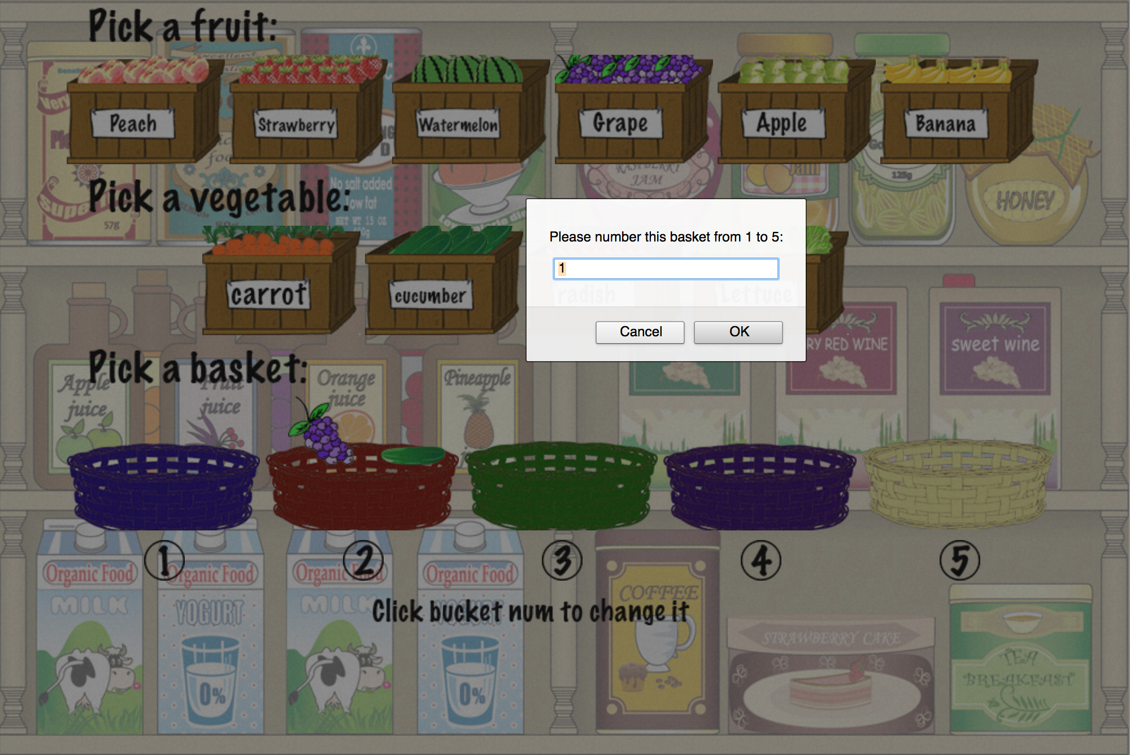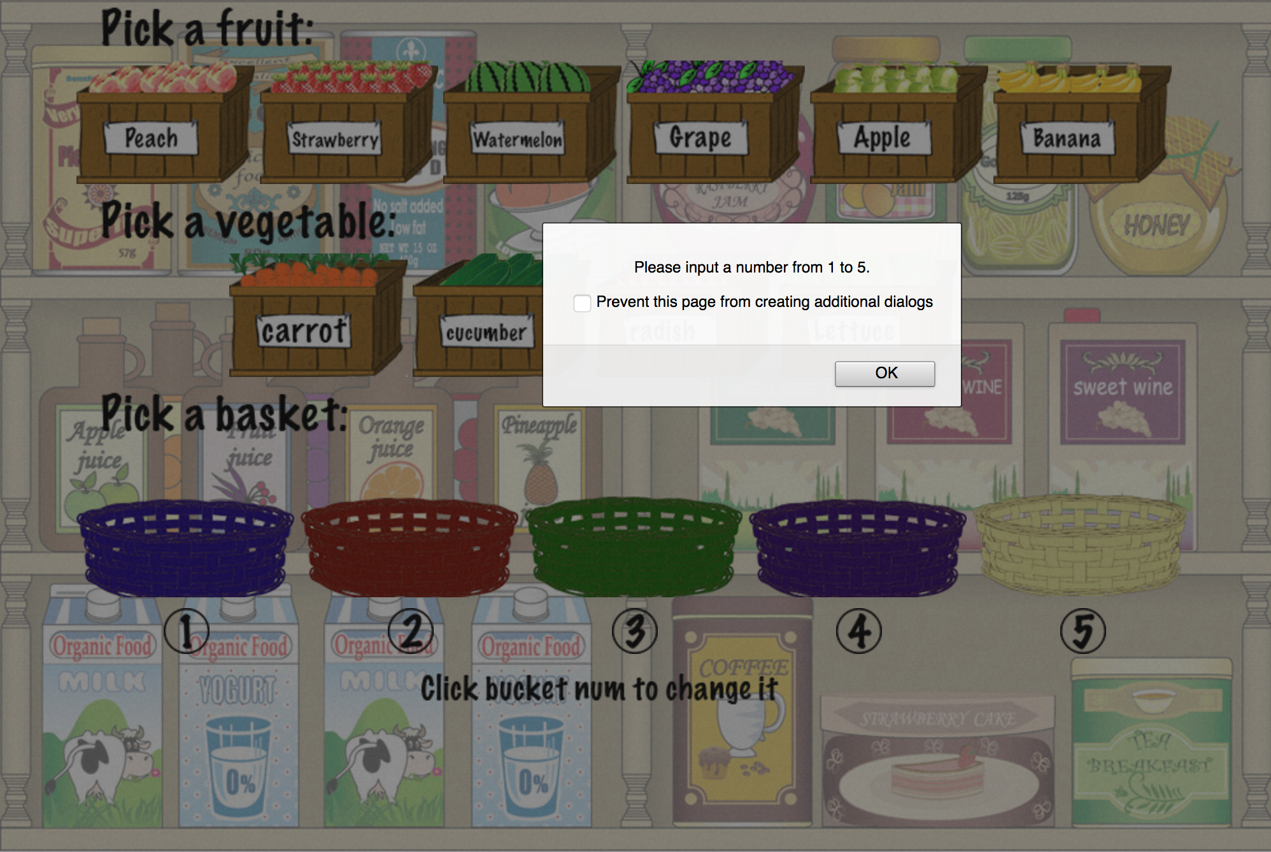

**5. After user numbering a basket, if there exist duplicate numbers, this webpage will show a friendly ‘caution’ at the bottom.**

